Take Assessment - ENetwork Final Exam - CCNA Exploration (Version 4.0)
1 Which OSI layer uses a connection-oriented protocol to ensure reliable delivery of data?
application layer
presentation layer
session layer
transport layer
2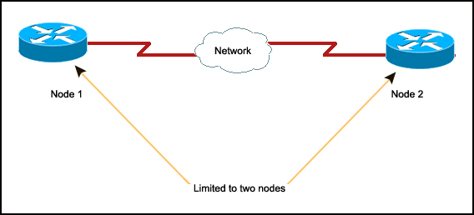
Refer to the exhibit. Which logical topology describes the exhibited network?
star
ring
point-to-point
multi-access
3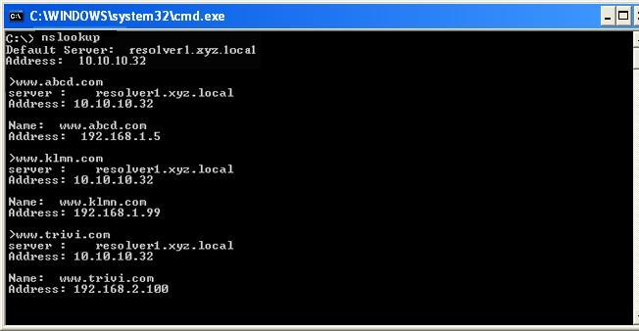
Refer to the exhibit. A technician uses the nslookup command on the PC and views the output that is displayed in the exhibit. What is the IP address of the primary domain name server used by the host?
10.10.10.32
192.168.1.5
192.168.1.99
192.168.2.100
4 An organization has been assigned network ID 10.10.128.0 and subnet mask 255.255.224.0. Which IP address range can be used for this organization?
10.10.128.0 to 10.10.160.255
10.10.128.0 to 10.10.159.255
10.10.128.0 to 10.10.192.255
10.10.128.0 to 10.10.0.159
10.10.128.0 to 10.10.159.0
5 What are two functions of the data link layer? (Choose two.)
It segments and reorders the data.
It exchanges data between programs that are running on the source and destination hosts.
It controls how data is placed onto the media.
It generates signals to represent the bits in each frame.
It encapsulates each packet with a header and a trailer to transfer it across the local media.
6 An organization wants to create a subnet of the IP network 172.16.0.0. This subnet will accommodate 1000 hosts. Which subnet mask should be assigned to this network?
255.255.0.0
255.255.248.0
255.255.252.0
255.255.254.0
255.255.255.0
255.255.255.128
7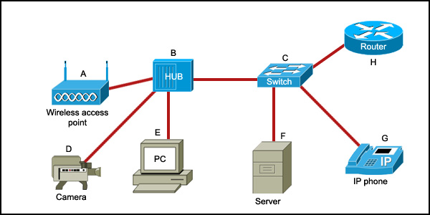
Refer to the exhibit. Which list refers only to end devices?
D,E,F,G
A,H,B,C
A,D,E,F
A,D,E,G
8 The network administrator wants to install a private application on a server. Which range of port numbers is normally assigned to this application to make it accessible by clients?
0 to 255
49152 to 65535
1024 to 49151
0 to 1023
9 What is the result of using the clock rate 56000 command at the serial interface of the router?
The interface is configured as a DCE device.
The interface timers are cleared.
The FastEthernet interface is made to emulate a serial interface by assigning it a timing signal.
The IP address for the serial interface is configured.
10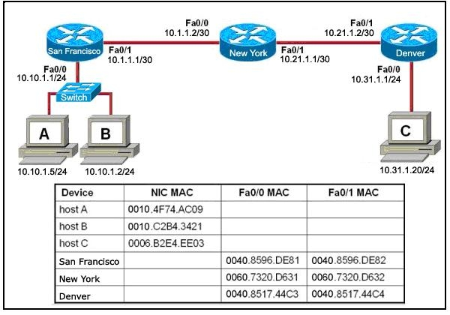
Refer to the exhibit. Host B attempts to establish a TCP/IP session with host C. During this attempt, a frame was captured at the FastEthernet interface fa0/1 of the San Francisco router. The packet inside the captured frame has the source IP address 10.10.1.2, and the destination IP address is 10.31.1.20. What is the destination MAC address of the frame at the time of capture?
0060.7320.D632
0060.7320.D631
0040.8517.44C3
0009.B2E4.EE03
0010.C2B4.3421
11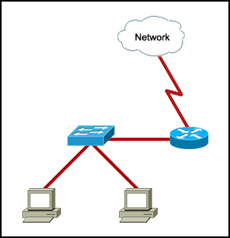
Refer to the exhibit. Which two facts can be determined about the topology? (Choose two.)
Three networks are needed.
Two logical address ranges are required.
A single broadcast domain is present.
Three collision domains are present.
Four networks are needed.
12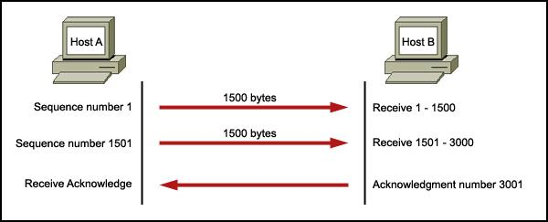
Refer to the exhibit. In a network, host A is sending data segments to host B. The flow control of the segments that are being exchanged is displayed. Which two statements are true about this communication? (Choose two.)
The initial window size is determined via the two-way handshake.
The window size for the TCP session that is represented is initially set to 3000 bytes.
Acknowledgment number 3001 indicates that host A will send the next segment with sequence number 3001.
Host B expects that the next received segment number will be 3000.
No more acknowledgments will be exchanged.
13 Which two types of media are useful for connecting two devices separated by a distance of 500 meters? (Choose two.)
10 BASE-T
1000 BASE-TX
10 BASE-2
1000 BASE LX
1000 BASE-SX
14 What are three characteristics of CSMA/CD? (Choose three.)
It monitors the media for presence of a data signal.
After detecting a collision, hosts can resume transmission after a random timer has expired.
A jam signal is used to ensure that all hosts are aware that a collision has occurred.
Devices can be configured with a higher transmission priority.
Data is transmitted only when the data signal is present.
It uses a token system to avoid collisions.
15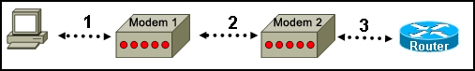
Refer to the exhibit. The network administrator wants to remotely access the CLI of the router from PC1 using modem 1. Which port of the router should be connected to modem 2 to enable this access?
console
Ethernet
auxiliary
serial
16 What is the effect of using the Router# copy running-config startup-config command on a router?
The contents of ROM will change.
The contents of RAM will change.
The contents of NVRAM will change.
The contents of flash will change.
17 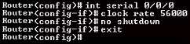
Refer to the exhibit. The serial interface of the router was configured with the use of the commands that are shown. The router cannot ping the router that is directly connected to interface serial 0/0/0. What should the network technician do to solve this problem?
Configure the description at interface serial 0/0/0.
Configure an IP address on interface serial 0/0/0.
Remove the no shutdown command at interface serial 0/0/0
Reboot the router.
18 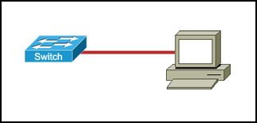
Refer to the exhibit. A technician has connected the PC to the switch using a Category 6 UTP cable. Which two statements are true about this connection? (Choose two.)
The cable that is used is an Ethernet crossover cable.
The transmit pin of the cable is terminated to the receive pin.
The maximum distance between the switch and the PC can be 100 m.
The maximum supported bandwidth is 1000 Mb/s.
The Category 6 cable simulates a point-to-point WAN link and is unusable for this type of connection.
19 Which password restricts Telnet access to the router?
enable
enable secret
console
VTY
20 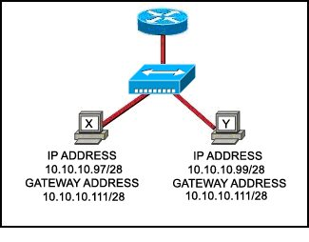
Refer to the exhibit. Communication for hosts X and Y is restricted to the local network. What is the reason for this?
Host X is assigned a network address.
Host Y is assigned a multicast address.
Host X and host Y belong to different networks.
The gateway addresses are broadcast addresses.
21 Which device should be used for routing a packet to a remote network?
access switch
DHCP server
hub
router
22 Which three statements are true about transport layer protocols? (Choose three.)
TCP and UDP manage communication between multiple applications.
TCP retransmits the packets for which the acknowledgment is not received.
TCP acknowledges received data.
UDP exchanges frames between the nodes of the network.
TCP has no mechanism to acknowledge transmission errors.
UDP uses windowing and sequencing to provide reliable transfer of data.
23 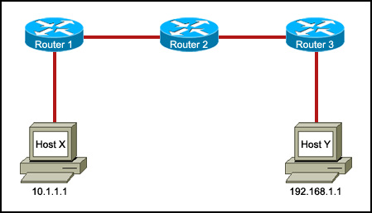
Refer to the exhibit. Host X is unable to communicate with host Y. Which command can be run at host X to determine which intermediary device is responsible for this failure?
telnet 192.168.1.1
ping 192.168.1.1
ftp 192.168.1.1
tracert 192.168.1.1
24 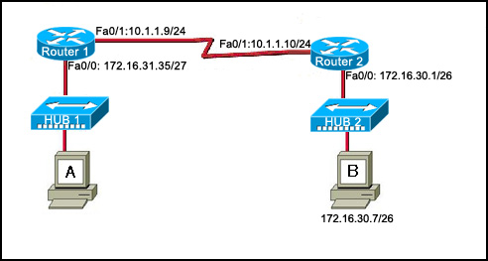
Refer to the exhibit. A host is connected to hub 1. Which combination of IP address, subnet mask, and default gateway can allow this host to function in the network?
IP address: 172.16.31.36 Subnet mask: 255.255.255.240 Default gateway: 172.16.31.35
IP address: 172.16.31.63 Subnet mask: 255.255.255.224 Default gateway: 172.16.31.35
IP address: 172.16.31.29 Subnet mask: 255.255.255.248 Default gateway: 172.16.31.35
IP address: 172.16.31.32 Subnet mask: 255.255.255.224 Default gateway: 172.16.31.35
IP address: 172.16.31.29 Subnet mask: 255.255.255.240 Default gateway: 172.16.30.1
IP address: 172.16.31.37 Subnet mask: 255.255.255.224 Default gateway: 172.16.31.35
25 Which three IPv4 addresses represent valid host addresses for a subnet? (Choose three.)
10.1.12.79/28
10.1.12.113/28
10.1.12.32/28
10.1.11.5/27
10.1.11.97/27
10.1.11.128/27
26 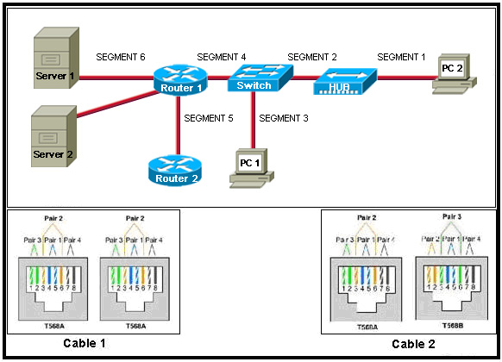
Refer to the exhibit. Cable 1 and Cable 2 are wired for specific physical layer requirements. Which three segments use Cable 2? (Choose three.)
Segment 1
Segment 2
Segment 3
Segment 4
Segment 5
Segment 6
28 Which three addresses belong to the category of public IP addresses? (Choose three.)
127.0.0.1
196.1.105.6
132.11.9.99
10.0.0.1
172.16.9.10
46.1.1.97
29 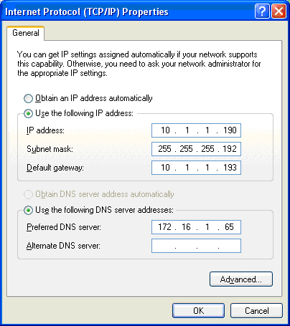
Refer to the exhibit. Which three statements are true about the IP configuration that is displayed? (Choose three.)
The assigned address is a private address.
The PC cannot communicate with the DNS server.
The network can have 126 hosts.
The prefix of the computer address is /26.
The IP address is routable on the Internet.
The IP address is a multicast address.
30 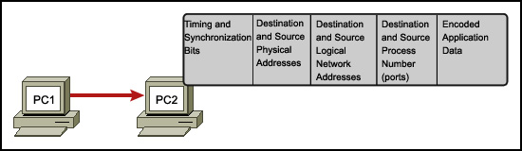
Refer to the exhibit. In a network, PC1 sends a message to PC2. The frame received at PC2 is shown. What information in this frame determines the correct destination application?
timing and synchronization bits
destination and source physical addresses
destination and source logical network addresses
destination and source process numbers
31 Which information is used by the router to determine the path between the source and destination hosts?
the host portion of the IP address
the network portion of the IP address
host default gateway address
the MAC address
32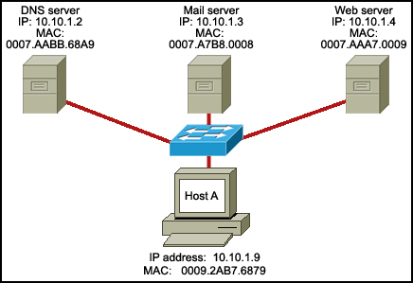
Refer to the exhibit. Host A is accessing multiple servers. Which combination of port number and address will uniquely identify a particular process running on a specific server?
MAC address of the server and port number of the service
IP address of the host and port number of the service
MAC address of the host and port number of the service
IP address of the server and port number of the service
33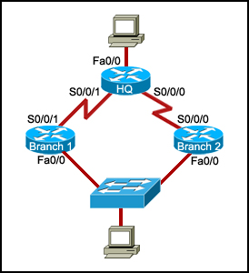
Refer to the exhibit. All devices in the network use default configurations. How many logical address ranges are required in this topology?
2
3
4
5
6
34 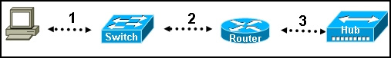
Refer to the exhibit. Each media link is labeled. What type of cable should be used to connect the different devices?
Connection 1 - rollover cable Connection 2 - straight-through cable Connection 3 - crossover cable
Connection 1 - straight-through cable Connection 2 - crossover cable Connection 3 - rollover cable
Connection 1 - crossover cable Connection 2 - rollover cable Connection 3 - straight-through cable
Connection 1 - crossover cable Connection 2 - straight-through cable Connection 3 - rollover cable
Connection 1 - straight-through cable Connection 2 - straight-through cable Connection 3 - straight-through cable
35 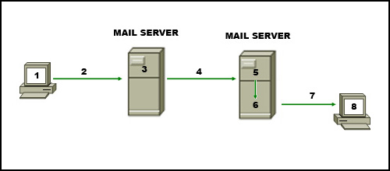
Refer to the exhibit. The diagram represents the process of sending e-mail between clients. Which list correctly identifies the component or protocol used at each numbered stage of the diagram?
1.MUA 2.MDA 3.MTA 4.SMTP 5.MTA 6.POP 7.MDA 8.MUA
1.MUA 2.POP 3.MDA 4.SMTP 5.MTA 6.MDA 7.SMTP 8.MUA
1.MUA 2.POP 3.SMTP 4.MDA 5.MTA 6.SMTP 7.POP 8.MUA
1.MUA 2.SMTP 3.MTA 4.SMTP 5.MTA 6.MDA 7.POP 8.MUA
36 Because of a security violation, the router password must be changed. What information can be learned from these configuration entries? (Choose two.)
Router(config)# line vty 0 4
Router(config-line)# password arj15
Router(config-line)# login
This configuration allows users to connect by using a modem.
Users must specify which line, 0 or 4, they wish to connect to when making a connection.
This configuration allows users to connect to the router via the use of the telnet command.
This configuration allows five users to make simultaneous connections to this router.
The configured password is automatically encrypted on the router.
37 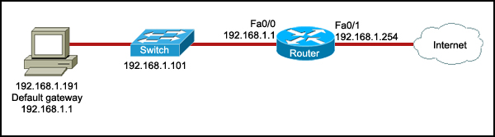
Refer to the exhibit. The NAT functionality of the router is enabled to provide Internet access to the PC. However, the PC is still unable to access the Internet. Which IP address should be changed to 209.165.201.1 to enable the PC to access the Internet?
192.168.1.191
192.168.1.101
192.168.1.1
192.168.1.254
38 A network technician wants to configure an IP address on a router interface by using the ip address 192.168.1.0 255.255.255.0 command. Which prompt should the technician see when entering this command?
Router>
Router(config-if)#
Router#
Router(config)#
39 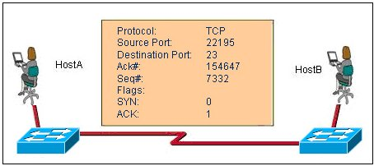
Refer to the exhibit. What two facts can be determined from the session information that is displayed? (Choose two.)
The protocol is a connection-oriented protocol.
This exchange is part of the three-way handshake.
The SYN flag is representing the initial establishment of a session.
The destination port indicates that a Telnet session has been initiated.
The source port does not support communication with the destination port that is listed.
40 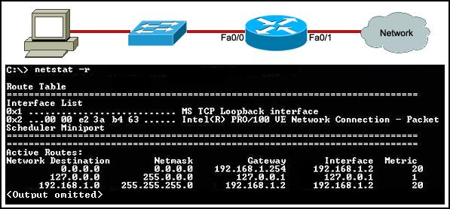
Refer to the exhibit. The PC, the routing table of which is displayed, is configured correctly. To which network device or interface does the IP address 192.168.1.254 belong?
PC
switch
router interface fa0/0
router interface fa0/1
41 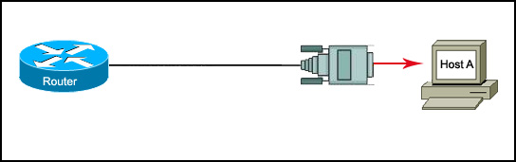
Refer to the exhibit. To create the initial configuration, a network technician connected host A to the router using the connection that is shown. Which statement is true about this connection?
It terminates at the Ethernet port of the router.
It provides out-of-band console access.
It terminates at the serial interface of the router.
It requires a Telnet client on host A to access the router.
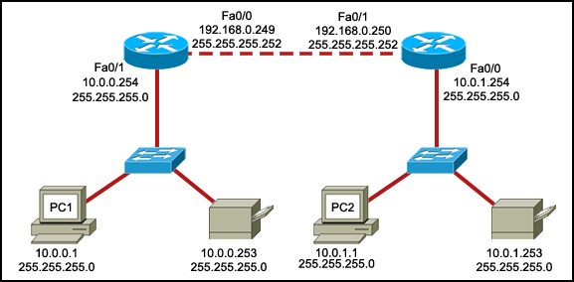
42
Refer to the exhibit. PC1 is unable to access PC2. To troubleshoot this problem, the technician needs to confirm that the next hop interface is operational. Which default gateway address should the technician ping from PC1 to confirm this?
10.0.0.254
192.168.0.249
192.168.0.250
10.0.1.254
43 Which three statements are true about network layer addressing? (Choose three.)
It uniquely identifies each host.
It assists in forwarding packets across internetworks.
It uses a logical 32-bit IPv4 address.
It is not a configurable address.
It is a physical address.
It identifies the host from the first part of the address.
44 A host is transmitting a video over the network. How does the transport layer allow this host to use multiple applications to transmit other data at the same time as the video transmission?
It uses error control mechanisms.
It uses a connectionless protocol only for multiple simultaneous transmissions.
It uses multiple Layer 2 source addresses.
It uses multiple port numbers.
45 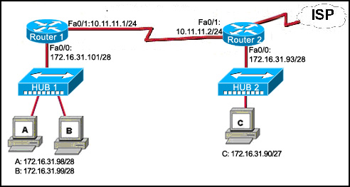
Refer to the exhibit. Host C is able to ping 127.0.0.1 successfully, but is unable to communicate with hosts A and B in the organization. What is the likely cause of the problem?
Hosts A and B are not on the same subnet as host C.
The IP addresses on the router serial interfaces are wrong.
The subnet mask on host C is improperly configured.
The FastEthernet interface fa0/0 of router 1 is wrongly configured.
CCNA1 Final Exam version 4.0 (100/100)
1.
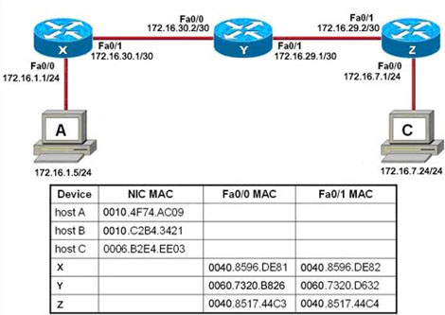
Host A attempts to establish a TCP/IP session with host C...
Refer to the exhibit. Host A attempts to establish a TSP/IP session with host C. During this attempt, a frame was captured at the FastEthernet interface fa0/1 of router Y. The packet inside the captured frame has the IP source address 172.16.1.5 and the destination IP address is 172.16.7.24 . What is the source MAC address of the frame at the time of capture?
0040.8596.DE82
0060.7320.B826
0060.7320.D632
0010.4F74.AC09
0040.8596.DE81
2.
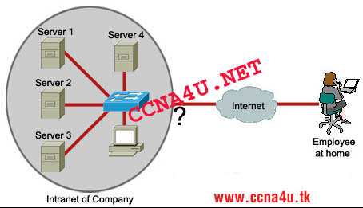
Refer to the exhibit. An employee wants to access the organization intranet from home. Which intermediary device should be used to connect the organization intranet to the Internet to enable this access?
hub
switch
router
wireless access point
3.
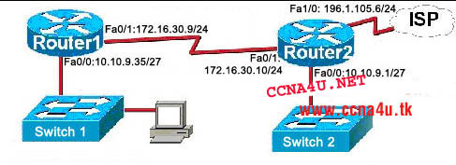
The host was disconnected from switch 2 and connected to switch 1. Which combination of IP address, subnet mask, and default gateway should be assigned to this host to allow it to function in the network?
Refer to the exhibit. The host was disconnected from switch 2 and connected to switch 1. Which combination of IP address, subnet mask, and default gateway should be assigned to this host to allow it to function in the network?
IP address: 10.10.9.37 Subnet mask: 255.255.255.240 Default gateway: 10.10.9.35
IP address: 10.10.9.37 Subnet mask: 255.255.255.224 Default gateway: 10.10.9.35
IP address: 10.10.9.29 Subnet mask: 255.255.255.248 Default gateway: 10.10.9.35
IP address: 10.10.9.32 Subnet mask: 255.255.255.224 Default gateway: 10.10.9.35
IP address: 10.10.9.37 Subnet mask: 255.255.255.224 Default gateway: 196.1.105.6
IP address: 10.10.9.63 Subnet mask: 255.255.255.224 Default gateway: 10.10.9.35
4. Which range of port numbers is assigned dynamically to client applications when initiating a connection to the server?
0 to 255
49152 to 65535
1024 to 49151
0 to 1023
5.
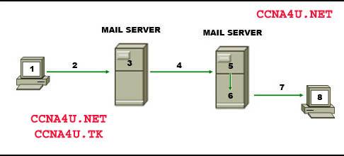
Refer to the exhibit. The diagram represents the process of sending e-mail between clients. Which list correctly identifies the component or protocol used at each numbered stage of the diagram?
1.MUA 2.MDA 3.MTA 4.SMTP 5.MTA 6.POP 7.MDA 8.MUA
1.MUA 2.POP 3.MDA 4.SMTP 5.MTA 6.MDA 7.SMTP 8.MUA
1.MUA 2.POP 3.SMTP 4.MDA 5.MTA 6.SMTP 7.POP 8.MUA
1.MUA 2.SMTP 3.MTA 4.SMTP 5.MTA 6.MDA 7.POP 8.MUA
6. Refer to the exhibit. While configuring a network, a technician wired each end of a Category 5e cable as shown. Which two statements are true about this setup? (Choose two.)
**The cable is suitable for connecting a switch to a router Ethernet port.
**The cable is suitable for connecting dissimilar types of devices.
The cable is unusable and must be rewired.
The cable is terminated in a way that the transmit pin is wired to the receive pin.
The cable simulates a point-to-point WAN link.
7. Refer to the exhibit. Which two facts can be determined about the topology? (Choose two.)
**Four collision domains are present.
One logical network is represented.
**Two broadcast domains are present.
Three networks are needed.
Three logical address ranges are required.
8.
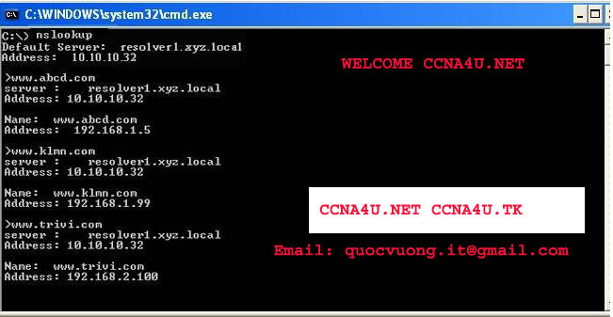
nslookup command on the PC
Refer to exhibit. A technician uses the nslookup command on the PC and views the output that is displayed in the exhibit. What is the IP address of the primary domain name server used by the host?
**10.10.10.32
192.168.1.5
192.168.1.99
192.168.2.100
9. Which subnet mask will allow 2040 hosts per subnet on the IP network 10.0.0.0?
255.255.0.0
255.255.254.0
255.255.252.0
**255.255.248.0
255.255.240.0
255.255.255.128
10. Which three addresses belong to the category of private IP addresses? (Choose three.)
**10.0.0.1
127.0.0.1
150.0.0.1
**172.16.0.1
**192.168.0.1
200.100.50.1
11.
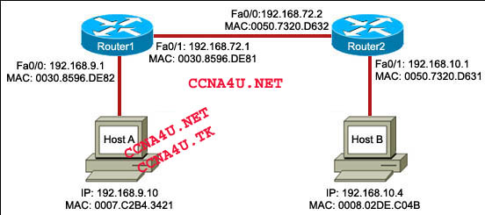
Host A is transmitting data to host B. Which address combination will be used as the data leaves the Router1 Fa0/1 interface?
Refer to the exhibit. Host A is transmitting data to host B. Which address combination will be used as the data leaves the Router1 Fa0/1 interface?
Destination IP: 192.168.72.2 Source MAC: 0007.C2B4.3421
**Destination IP: 192.168.10.4 Source MAC: 0030.8596.DE81
Destination IP: 192.168.10.4 Source MAC: 0007.C2B4.3421
Destination IP: 192.168.72.2 Source MAC: 0030.8596.DE81
12. Which memory contents will change as a result of using the Router# erase startup-config command on a router?
RAM
ROM
flash
**NVRAM
13. What are two characteristics of the data link layer? (Choose two.)
**It segments and reorders the data.
It exchanges the frames between nodes.
**It defines the method by which network devices place data onto the media.
It manages the transfer of data between the processes that run on each host.
It retrieves signals from the media and restores them to their bit representations.
14. Refer to the exhibit. The NAT functionality of the router is enabled to provide the PC with Internet access. Which IP address can be assigned to router interface Fa0/0?
10.0.0.1
172.16.1.1
**209.165.201.1
192.168.1.1
15.
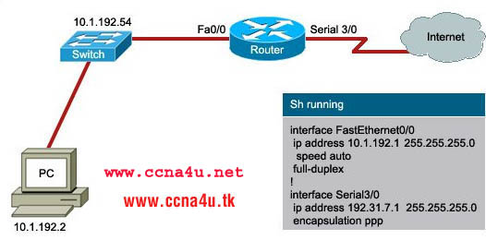
A user wants to access the Internet from the PC. A part of the running configuration of the router is shown
Refer to the exhibit. A user wants to access the Internet from the PC. A part of the running configuration of the router is shown. Which default gateway IP address should be configured at the PC to enable this access?
10.1.192.2
10.1.192.54
**10.1.192.1
192.31.7.1
16. Refer to the exhibit. A network technician wants to connect host A to the console of a Cisco switch to initialize the configuration. What type of cable is required for this connection?
straight-through cable
crossover cable
**rollover cable
serial cable
17. A network administrator wants to restrict access to the router privileged EXEC mode. Which password should the administrator use?
**enable
aux
console
VTY
18. What are three characteristics of CSMA/CD? (Choose three.)
**Devices listen to the media and transmit data only when they cannot detect another signal on the media.
**All devices on the media can hear all communications.
Devices communicate based on a configured priority.
After a collision occurs, the devices that caused the collision have first priority when attempting to retransmit.
**When a collision occurs, all devices stop transmitting for a randomly generated period of time.
CSMA/CD uses a token system to avoid collisions.
19. Refer to the exhibit. The router of the company failed and was replaced. After the replacement, hosts C and D in the Education office are able to ping each other, but they are unable to access the hosts in the Accounts office. What is the likely cause of the problem?
The IP address at the fa0/0 interface of the router is incorrectly configured.
**The subnet mask at the fa0/1 interface of the router is incorrectly entered.
The IP address at the serial interface of the router is incorrectly configured.
The hosts in the Accounts office are not on the same subnet as the hosts in the Education office.
20. Refer to the exhibit. Host A and B are unable to communicate with each other. What is the reason for this?
Host A is assigned a network address.
Host B is assigned a multicast address.
Host A and host B belong to different networks.
**The gateway addresses are network addresses.
21. Refer to the exhibit. A user wants to view the current configuration. The output of the ipconfig/all command is displayed in the exhibit. What three facts can be determined from the output? (Choose three.)
The IP address is obtained from the DHCP server.
**This PC cannot communicate with other networks.
**The network can have 14 hosts.
The prefix of the computer address is /25.
The IP address is routable on the Internet.
**The assigned address is a private address.
22. Which two types of media can provide bandwidth up to 1 Gb/s? (Choose two.)
10 BASE-T
100 BASE-T
100 BASE-FX
**1000 BASE-TX
**1000 BASE-SX
23. Refer to the exhibit. RouterB is configured properly.
The Ethernet interface Fa0/0 of RouterA is configured with the use of the commands that are shown However, a ping from the Fa0/0 interface of RouterA to the Fa0/0 interface of RouterB is unsuccessful. What action should be taken on RouterA to solve this problem?
Use the description command on the FastEthernet interface Fa0/0.
Configure the clock rate of the FastEthernet interface Fa0/0.
**Use the no shutdown command on the FastEthernet interface Fa0/0.
Reboot the router.
24. Refer to the exhibit. Host A wants to connect to host B on a different network. Which three IP addresses can be assigned to host A to enable this connectivity? (Choose three.)
172.16.11.36
172.16.11.95
**172.16.11.88
**172.16.11.70
172.16.11.64
**172.16.11.67
25. Refer to the exhibit. Host A wants to access e-mail. Which destination socket number will be used to communicate this request?
10.10.1.2:53
0007.A7B8.0008:25
10.10.1.3:23
**10.10.1.3:25
26. A network administrator uses the copy startup-config running-config command on a router to make configuration changes. Which component is affected by this command?
ROM
**NVRAM
RAM
flash
27. Refer to the exhibit. In a network, Hosts A and B are exchanging segments at the transport layer. Which two statements are true about this exchange? (Choose two.)
Host A is transferring files to host B using FTP.
**Host A will send the next segment containing data for this session starting with byte number 11
The segment from the destination host indicates that 11 bytes have been received successfully
**Host A is initiating a Telnet session to host B
Host B can send the next segment of the data starting with byte number 2
28. How does the transport layer allow a host to maintain multiple, simultaneous communication streams across different applications?
It uses error control mechanisms.
**It uses a connectionless protocol only for multiple simultaneous transmissions.
It uses multiple Layer 2 source addresses.
It uses multiple ports.
29. What information is contained in the header of Layer 3 to help data delivery?
port number
device physical address
**destination host logical address
virtual connection identifier
30. Refer to the exhibit. The tracert command used from host X to host Y was successful. What is the correct sequence of intermediary network devices that will be present in the trace list?
switch A, switch D, switch G, host Y
**router B, router E, router F, host Y
switch A, router B, switch D, router E, router F, switch G, host Y
switch A, router B, router F, switch G, host Y
31. While configuring a router, a network technician wants to name the router. Which prompt should the technician see when entering the hostname command?
Router>
Router#
**Router(config)#
Router(config-line)#
32. An organization has decided to use IP addresses in the range 172.20.128.0 to 172.20.143.255. Which combination of network ID and subnet mask identifies all IP addresses in this range?
Network ID: 172.20.128.0 Subnet mask: 255.255.255.0
Network ID: 172.20.128.0 Subnet mask: 255.255.0.0
Network ID: 172.20.128.0 Subnet mask: 255.255.224.0
**Network ID: 172.20.128.0 Subnet mask: 255.255.240.0
Network ID: 172.20.128.0 Subnet mask: 255.255.255.240
33. Refer to the exhibit. Which logical topology describes the exhibited network?
star
**ring
point-to-point
multi-access
34. Refer to the exhibit. All devices in the network use default configurations. How many broadcast domains are there in this topology?
3
**5
7
9
11
35. Which three IPv4 addresses represent valid network addresses for a subnet? (Choose three.)
**192.168.9.64/28
192.168.9.146/28
**192.168.9.96/28
192.168.9.129/26
192.168.9.51/26
**192.168.9.64/26
36. Two routers are connected via their serial ports in a lab environment. The routers are configured with valid IP addresses, but they cannot ping each other. The show interface serial0/0 command shows that the serial0/0 interface is up but the line protocol is down. What could be the cause of this problem?
The no shutdown command has not been applied to the interfaces.
**The clock rate command has not been entered on the DCE interface.
The interface timers are not cleared.
The FastEthernet interface is emulating a serial interface by assigning it a timing signal.
37. Which device should be used for enabling a host to communicate with another host on a different network?
switch
hub
**router
host
38. Refer to the exhibit. The network administrator uses the netstat command to display the open, active, and running TCP connections on a networked host. The exhibit displays the output of this command. Which two facts can be determined from this output for accessing www.cisco.com? (Choose two.)
The source port indicates that the session is an http session.
The connection is not successful.
**The source port of the host is 3166.
**The destination port is 80.
The source port does not support communication with the destination port that is listed.
The source port indicates that a UDP session has been initiated.
39. Which OSI layer uses the header information to reassemble the data segments into streams?
application layer
network layer
presentation layer
session layer
**transport layer
40. Which three statements are true about transport layer protocols? (Choose three.)
**The UDP transport layer protocol provides for low overhead data delivery.
**The TCP transport layer protocol uses windowing and acknowledgments for reliable transfer of data.
**The TCP and UDP port numbers are used by application layer protocols.
The TCP transport layer protocol provides services to direct the data packets to their destination hosts.
The UDP transport layer protocol is a connection-oriented protocol.
The UDP transport layer protocol keeps track of all the data segments in each conversation.
41. To enhance security in a network, the network administrator uses these commands:
Router(config)# line console 0
Router(config-line)# password j1mdi2
Router(config-line)# login
What two conclusions are evident from these commands? (Choose two.)
**Users who attempt to connect to the console port of the router must enter a password.
**The entries permit access through the console by the use of j1mdi2 as the password.
The entries eliminate the need for authentication.
Access through the console will be denied because the console configuration is incomplete.
The entries prevent passwords from being displayed as plain text.
42. Refer to the exhibit. Each media link is labeled. What type of cable should be used to connect the different devices?
Connection 1 - straight-through cable Connection 2 - straight-through cable Connection 3 - crossover cable
Connection 1 - straight-through cable Connection 2 - crossover cable Connection 3 - rollover cable
Connection 1 - crossover cable Connection 2 - rollover cable Connection 3 - straight-through cable
**Connection 1 - crossover cable Connection 2 - straight-through cable Connection 3 - crossover cable
Connection 1 - straight-through cable Connection 2 - rollover cable Connection 3 - crossover cable
43. Refer to the exhibit. The headers added at each layer are shown.
Which layer adds the destination and source process numbers to ensure that data is delivered to the correct application?
physical layer
data link layer
network layer
**transport layer
44. Which three statements are true about network layer addressing? (Choose three.)
It uses the last octet of the IP address to identify the network.
**It supports data communications between networks.
**It is configured by the network technician.
It is a 16-bit IPv4 address.
It prevents broadcasts.
**It uniquely identifies each host.
45. Refer to the exhibit. A PC is connected to a network. Which action will verify that the PC can communicate with its default gateway?
Use the ping 127.0.0.1 command.
Use the ipconfig command.
Use the ipconfig/all command.
**Use the ping 10.0.0.254 command.
46. Refer to the exhibit. Host A sends a frame with the destination MAC address as FFFF.FFFF.FFFF. What action will the switch take for this frame?
It will drop the frame.
It will send the frame back to host A.
**It will send the frame to all hosts except host A.
It will forward the frame to the default gateway.
47. Refer to the exhibit. The network administrator remotely accesses the CLI of RouterB from PC1 using a secure connection. Which statement is true about this connection?
The Telnet server process is running on PC1.
Only the exchange of the Telnet username and password is encrypted.
The GET request is sent to RouterA to retrieve data.
**The SSH service is used to connect PC1 to RouterB.
48. Which OSI layer uses the header information to reassemble the data segments into streams?
application layer
network layer
presentation layer
session layer
**transport layer
49. Refer to the exhibit. A router, the table of which is shown, receives a packet that is destined for 192.168.9.4. How will the router treat the packet?
It will drop the packet.
It will forward the packet via FastEthernet 0/1.
**It will forward the packet to the next hop address.
It will forward the packet to 172.16.2.0
50. Refer to the exhibit. Cable 1 and Cable 2 are wired for specific physical layer requirements. The table lists each segment by number and the cable that connects the network components on that segment. Which three segments have the correct cables installed? (Choose three.)
**segment 1
segment 2
segment 3
**segment 4
**segment 5
segment 6
TEST IS ABOVE 100%
CCNA WAN 94%

1. A technician has been asked to run Cisco SDM one-step lockdown on the router of a customer. What will be the result of this process?
Traffic is only forwarded from SDM-trusted Cisco routers.
Security testing is performed and the results are saved as a text file stored in NVRAM.
The router is tested for potential security problems and any necessary changes are made.
All traffic entering the router is quarantined and checked for viruses before being forwarded.
2. Refer to the exhibit. A network administrator is trying to configure a router to use SDM but it is not functioning correctly. What could be the problem?
The username and password are not configured correctly.
The authentication method is not configured correctly.
The HTTP timeout policy is not configured correctly.
The vtys are not configured correctly.
3. Refer to the exhibit. How is the TCP/IP configuration information specified by the default-router and dns-server commands made available?
The TCP/IP information is forwarded to a 10.0.1.3 to be supplied to DHCP clients.
The TCP/IP information is used by DHCP clients that are configured to request a configuration from R1.
The TCP/IP information is supplied to any DHCP client on the network connected to the FastEthernet 0/0 interface of R1.
The TCP/IP information is applied to each packet that enters R1 through the FastEthernet 0/0 interface that are hosts on the 10.0.1.0 /24 network except packets from addresses 10.0.1.2, 10.0.1.16, and 10.0.1.254.
4. What is a major characteristic of a worm?
malicious software that copies itself into other executable programs
tricks users into running the infected software
a set of computer instructions that lies dormant until triggered by a specific event
exploits vulnerabilities with the intent of propagating itself across a network
5. Refer to the exhibit. What can be concluded from the exhibited output of the debug ip nat command?
The 10.1.1.225 host is exchanging packets with the 192.168.0.10 host.
The native 10.1.200.254 address is being translated to 192.168.0.10.
The 192.168.0.0/24 network is the inside network.
Port address translation is in effect.
6. A technician is talking to a colleague at a rival company and comparing DSL transfer rates between the two companies. Both companies are in the same city, use the same service provider, and have the same rate/service plan. What is the explanation for why Company A reports higher download speeds than Company B?
Company B has a higher volume of POTS voice traffic than Company A.
Company B shares the conection to the DSLAM with more clients than Company A.
Company A only uses microfilters on branch locations.
Company A is closer to the service provider.
7. Refer to the exhibit. Which statement correctly describes how Router1 processes an FTP request entering interface s0/0/0, destined for an FTP server at IP address 192.168.1.5?
It matches the incoming packet to the access-list 201 permit any any statement and allows the packet into the router.
It reaches the end of ACL 101 without matching a condition and drops the packet because there is no access-list 101 permit any any statement.
It matches the incoming packet to the access-list 101 permit ip any 192.168.1.0 0.0.0.255 statement, ignores the remaining statements in ACL 101, and allows the packet into the router.
It matches the incoming packet to the access-list 201 deny icmp 192.168.1.0 0.0.0.255 any statement, continues comparing the packet to the remaining statements in ACL 201 to ensure that no subsequent statements allow FTP, and then drops the packet.
8. Refer to the exhibit. Which two conclusions can be drawn from the output shown? (Choose two.)
This network is experiencing congestion.
The Frame Relay connection is in the process of negotiation.
Data is not flowing in this network.
The network is discarding eligible packets.
The DLCI is globally significant.
9. A system administrator must provide Internet connectivity for ten hosts in a small remote office. The ISP has assigned two public IP addresses to this remote office. How can the system administrator configure the router to provide Internet access to all ten users at the same time?
Configure DHCP and static NAT.
Configure dynamic NAT for ten users.
Configure static NAT for all ten users.
Configure dynamic NAT with overload.
10. Refer to the exhibit. Company ABC expanded its business and recently opened a new branch office in another country. IPv6 addresses have been used for the company network. The data servers Server1 and Server2 run applications which require end-to-end functionality, with unmodified packets that are forwarded from the source to the destination. The edge routers R1 and R2 support dual stack configuration. What solution should be deployed at the edge of the company network in order to successfully interconnect both offices?
a new WAN service supporting only IPv6
NAT overload to map inside IPv6 addresses to outside IPv4 address
a manually configured IPv6 tunnel between the edge routers R1 and R2
static NAT to map inside IPv6 addresses of the servers to an outside IPv4 address and dynamic NAT for the rest of the inside IPv6 addresses
11. Refer to the exhibit. You are a network administrator who has been tasked with completing the Frame Relay topology that interconnects two remote sites. How should the point-to-point subinterfaces be configured on HQ to complete the topology?
HQ(config-subif)#frame-relay interface-dlci 103 on Serial 0/0/0.1
HQ(config-subif)#frame-relay interface-dlci 203 on Serial 0/0/0.2
HQ(config-subif)#frame-relay interface-dlci 301 on Serial 0/0/0.1
HQ(config-subif)# frame-relay interface-dlci 302 on Serial 0/0/0.2
HQ(config-subif)#frame-relay map ip 172.16.1.1 103 broadcast on Serial 0/0/0.1
HQ(config-subif)#frame-relay map ip 172.16.2.2 203 broadcast on Serial 0/0/0.2
HQ(config-subif)#frame-relay map ip 172.16.1.1 301 broadcast on Serial 0/0/0.1
HQ(config-subif)#frame-relay map ip 172.16.2.2 302 broadcast on Serial 0/0/0.2
12. An established company has recently transitioned from outsourced LAN support to a completely in-house staff. The outsourcing company is no longer in business, so no records are available. There are many user complaints about application speed and availability. What two considerations apply to this situation? (Choose two.)
A network utilization baseline should quickly reveal application availability.
A period of 24 to 48 hours should provide a sufficient baseline to track normal network activity.
It is easier to start with monitoring all available data inputs on application servers, and then fine-tune to fewer variables along the way.
The initial baseline results have little relevance to current values after the network has been modified or grown in usage.
When it is practical, network administrators should attempt to automate the collection of performance data and stay away from manual collection.
Creating a network baseline data helps determine device thresholds for alerting.
13. Which combination of Layer 2 protocol and authentication should be used to establish a link without sending authentication information in plain text between a Cisco and a non-Cisco router?
PPP with PAP
PPP with CHAP
HDLC with PAP
HDLC with CHAP
14. An administrator is unable to receive e-mail. While troubleshooting the problem, the administrator is able to ping the local mail server IP address successfully from a remote network and can successfully resolve the mail server name to an IP address via the use of the nslookup command. At what OSI layer is the problem most likely to be found?
physical layer
data link layer
network layer
application layer
15. When configuring a Frame Relay connection, what are two instances when a static Frame Relay map should be used? (Choose two.)
when the remote router is a non-Cisco router
when the remote router does not support Inverse ARP
when the local router is using IOS Release 11.1 or earlier
when broadcast traffic and multicast traffic over the PVC must be controlled
when globally significant rather than locally significant DLCIs are being used
16. Which three statements are true about creating and applying access lists? (Choose three.)
Access list entries should filter in the order from general to specific.
One access list per port per protocol per direction is permitted.
Standard ACLs should be applied closest to the source while extended ACLs should be applied closest to the destination.
There is an implicit deny at the end of all access lists.
Statements are processed sequentially from top to bottom until a match is found.
The inbound keyword refers to traffic entering the network from the router interface where the ACL is applied.
17. Which technology would provide the highest bandwidth connections between company sites at the lowest cost?
broadband Internet site-to-site VPN connections
satellite based network connections
dedicated point-to-point circuits
Frame Relay PVCs
18. Refer to the exhibit. This serial interface is not functioning correctly. Based on the output shown, what is the most likely cause?
improper LMI type
interface reset
PPP negotiation failure
unplugged cable
19. What three statements describe the roles of devices in a WAN? (Choose three.)
A CSU/DSU terminates a digital local loop.
A modem terminates a digital local loop.
A CSU/DSU terminates an analog local loop.
A modem terminates an analog local loop.
A router is commonly considered a DTE device.
A router is commonly considered a DCE device.
20. A network administrator is instructing a technician on best practices for applying ACLs. Which suggestion should the administrator provide?
Named ACLs are less efficient than numbered ACLs.
Standard ACLs should be applied closest to the core layer.
ACLs applied to outbound interfaces are the most efficient.
Extended ACLs should be applied closest to the source that is specified by the ACL.
21. Refer to the exhibit. Branch A has a Cisco router. Branch B has a non-Cisco router set for IETF encapsulation. After the commands shown are entered, R2 and R3 fail to establish the PVC. The R2 LMI is Cisco, and the R3 LMI is ANSI. The LMI is successfully established at both locations. Why is the PVC failing?
The PVC to R3 must be point-to-point.
LMI types must match on each end of a PVC.
The ietf parameter is missing from the frame-relay map ip 10.10.10.3 203 command.
The PVCs at R2 use different encapsulation types. A single port can only support one encapsulation type.
22. Which statement is true regarding wildcard masks?
The wildcard mask and subnet mask perform the same function.
The wildcard mask is always the inverse of the subnet mask.
A "0" in the wildcard mask identifies IP address bits that must be checked.
A "1" in the wildcard mask identifies a network or subnet bit.
23. Refer to the exhibit. What is placed in the address field in the header of a frame that will travel from the DC office of ABC Company to the Orlando office?
MAC address of the Orlando router
MAC address of the DC router
192.168.1.25
192.168.1.26
DLCI 100
DLCI 200
24 .A company is looking for a WAN solution to connect its headquarters site with four remote sites. What advantage would dedicated leased lines provide to the customer compared to a shared Frame Relay solution?
lower cost
lower latency and jitter
variable bandwidth capacity
fewer physical router interfaces
25. Refer to the exhibit. RIPv2 has been configured on all routers in the network. Routers R1 and R3 do not receive RIP routing updates. On the basis of the provided configuration, what should be enabled on router R2 to remedy the problem?
proxy ARP
CDP updates
SNMP services
RIP authentication
26. What are the symptoms when the s0/0/0 interface on a router is attached to an operational CSU/DSU that is generating a clock signal, but the far end router on the point-to-point link has not been activated?
show controllers indicates cable type DCE V.35. show interfaces s0/0/0 indicates serial down, line protocol down.
show controllers indicates cable type DCE V.35. show interfaces s0/0/0 indicates serial up, line protocol down.
show controllers indicates cable type DTE V.35. show interfaces s0/0/0 indicates serial up, line protocol down.
show controllers indicates cable type DTE V.35. show interfaces s0/0/0 indicates serial down, line protocol down.
27. Which statement about a VPN is true?
VPN link establishment and maintenance is provided by LCP.
DLCI addresses are used to identify each end of the VPN tunnel.
VPNs use virtual Layer 3 connections that are routed through the Internet.
Only IP packets can be encapsulated by a VPN for tunneling through the Internet.
28. Refer to the exhibit. Partial results of the show access-lists and show ip interface FastEthernet 0/1 commands for router R3 are shown. There are no other ACLs in effect. Host A is unable to telnet to host B. Which action will correct the problem but still restrict other traffic between the two networks?
Apply the ACL in the inbound direction.
Apply the ACL on the FastEthernet 0/0 interface.
Reverse the order of the TCP protocol statements in the ACL.
Modify the second entry in the list to permit tcp host 192.168.10.10 any eq telnet .
29. Refer to the exhibit. What happens if the network administrator issues the commands shown when an ACL alled Managers already exists on the router?
The commands overwrite the existing Managers ACL.
The commands are added at the end of the existing Managers ACL.
The network administrator receives an error stating that the ACL already exists.
The commands will create a duplicate Managers ACL containing only the new commands being entered.
30. Which three statements accurately describe a security policy? (Choose three.)
It creates a basis for legal action if necessary.
It defines a process for managing security violations.
It defines acceptable and unacceptable use of network resources.
The remote access policy is a component of the security policy that governs acceptable use of e-mail systems.
It is kept private from users to prevent the possibility of circumventing security measures.
It provides step-by-step procedures to harden routers and other network devices.
31. Refer to the exhibit. The link between the CTRL and BR_1 routers is configured as shown in the exhibit. Why are the routers unable to establish a PPP session?
The clock rate must be 56000.
The usernames are misconfigured.
The IP addresses are on different subnets.
The clock rate is configured on the wrong end of the link.
The CHAP passwords must be different on the two routers.
Interface serial 0/0/0 on CTRL must connect to interface serial 0/0/1 on BR_1.
32. What effect would the Router1(config-ext-nacl)# permit tcp 172.16.4.0 0.0.0.255 any eq www command have when implemented inbound on the f0/0 interface?
All TCP traffic is permitted, and all other traffic is denied.
The command is rejected by the router because it is incomplete.
All traffic from 172.16.4.0/24 is permitted anywhere on any port.
Traffic originating from 172.16.4.0/24 is permitted to all TCP port 80 destinations.
33. What can a network administrator do to recover from a lost router password?
use the copy tftp: flash: command
boot the router to bootROM mode and enter the b command to load the IOS manually
telnet from another router and issue the show running-config command to view the password
boot the router to ROM monitor mode and configure the router to ignore the startup configuration when it initializes
34. A router in a Frame Relay network needs to forward a message received from a host. What two methods does the router use to identify the correct VC to forward the message? (Choose two.)
The router forwards the frame to all ports in the network and learns the address from the reply frame.
The destination host IP address is embedded in the DLCI.
The router searches Inverse ARP tables for maps of DLCIs to IP addresses.
A table of static mappings can be searched.
The router broadcasts a request for the required IP address.
35. Refer to the exhibit. From the output of the show interface commands, at which OSI layer is a fault indicated?
application
transport
network
data link
physical
36. Refer to the exhibit. The network administrator creates a standard access control list to prohibit traffic from the 192.168.1.0/24 network from reaching the 192.168.2.0/24 network while still permitting Internet access for all networks. On which router interface and in which direction should it be applied?
interface fa0/0/0, inbound
interface fa0/0/0, outbound
interface fa0/0/1, inbound
interface fa0/0/1, outbound
37. Refer to the exhibit. The SSH connections between the remote user and the server are failing. The correct configuration of NAT has been verified. What is the most likely cause of the problem?
SSH is unable to pass through NAT.
There are incorrect access control list entries.
The access list has the incorrect port number for SSH.
The ip helper command is required on S0/0/0 to allow inbound connections.
38. Refer to the exhibit. A technician issues the show interface s0/0/0 command on R1 while troubleshooting a network problem. What two conclusions can be determined by from the output shown? (Choose two.)
The bandwidth has been set to the value of a T1 line.
Encapsulation should of this inteface be changed to PPP.
There is no failure indicated in an OSI Layer 1 or Layer 2.
The physical connection between the two routers has failed.
The IP address of S0/0 is invalid, given the subnet mask being used.
39. Refer to the exhibit. A packet is being sent from Host A to Host B through the VPN tunnel between R1 and R3. When the packet first arrives at R3, what are the source and destination IP addresses of the packet?
Source 192.168.1.2 - Destination 192.168.4.2
Source 192.168.3.1 - Destination 192.168.3.2
Source 192.168.2.1 - Destination 192.168.3.2
Source 192.168.3.1 - Destination 192.168.4.2
40. An administrator is configuring a dual stack router with IPv6 and IPv4 using RIPng. The administrator receives an error message when trying to enter the IPv4 routes into RIPng. What is the cause of the problem?
RIPng is incompatible with dual-stack technology.
All interfaces have been configured with the incorrect IPv4 addresses.
RIPv1 or RIPv2 needs to be configured in addition to RIPng to successfully use IPv4.
When IPv4 and IPv6 are configured on the same interface, all IPv4 addresses are shut down in favor of the newer technology.
41. Which wireless solution can provide mobile users with non line-of-sight broadband Internet access at speeds comparable to DSL or cable?
Wi-Fi
WiMAX
satellite
Metro Ethernet
42. A network administrator added two switches and a new VLAN over the past weekend. How can the administrator determine if the additions and changes improved performance and availability on the company intranet?
Perform a baseline test and compare the current values to values that were obtained in previous weeks.
Interview departmental secretaries and determine if they think load time for web pages is improved.
Compare the hit counts on the company web server for the current week to the values that were recorded from previous weeks.
Performance on the intranet can be determined by monitoring load times of company web pages from remote sites.
43. Refer to the exhibit. The network administrator is adding R1 to an existing network. As a part of the corporate IT procedures, the administrator attempts to back up the router Cisco IOS software of R1 and receives the output shown. The network administrator then attempts unsuccessfully to ping the TFTP server from the console session. What should be done next to isolate this problem?
From R2, validate that interface Fa0/0 is operational.
From the TFTP server, verify that the software on the TFTP server is operational.
From the TFTP server, confirm there is enough room on the TFTP server for the Cisco IOS software.
From the console session, make sure that R1 has a route to the network where the TFTP server resides.
44. What functionality do access control lists provide when implementing dynamic NAT on a Cisco router?
defines which addresses can be translated
defines which addresses are assigned to a NAT pool
defines which addresses are allowed out of the router
defines which addresses can be accessed from the inside network
45. A network administrator is working with an applications team to fix a problem that a server based application is having with response time. The administrator has examined the network portions of the data path and identified several possible problem areas. The applications team has simultaneously identified potential issues with the current release of software. The network administrator begins addressing the network issues while the applications team implements software patches.
Which statement applies to this situation?
Changes to the network will reveal problems that are caused by the new patches.
Scheduling will be more difficult if the network and software teams work independently.
It will be difficult to isolate the problem if two teams are implementing changes independently.
Results from changes will be easier to reconcile and document if each team works in isolation.
46. Refer to the exhibit. R1 is performing NAT overload for the 10.1.1.0/24 inside network. Host A has sent a packet to the web server. What is the destination IP address of the return packet from the web server?
10.1.1.2:1234
172.30.20.1:1234
172.30.20.1:3333
192.168.1.2:80
47. Which three guidelines would help contribute to creating a strong password policy? (Choose three.)
Once a good password is created, do not change it.
Deliberately misspell words when creating passwords.
Create passwords that are at least 8 characters in length.
Use combinations of upper case, lower case, and special characters.
Write passwords in locations that can be easily retrieved to avoid being locked out.
Use long words found in the dictionary to make passwords that are easy to remember.
48. What will be the result of adding the command ip dhcp excluded-address 172.16.4.1 172.16.4.5 to the configuration of a local router that has been configured as a DHCP server?
Traffic that is destined for 172.16.4.1 and 172.16.4.5 will be dropped by the router.
Traffic will not be routed from clients with addresses between 172.16.4.1 and 172.16.4.5.
The DHCP server function of the router will not issue the addresses between 172.16.4.1 and 172.16.4.5.
The router will ignore all traffic that comes from the DHCP servers with addresses 172.16.4.1 and 172.16.4.5.
49. Which two statements are true about IPv6? (Choose two.)
Security options are build into IPv6.
IPv6 addresses require less router overhead to process.
IPv6 can only be configured on an interface that does not have IPv4 on it.
There is no way to translate between IPv4 addresses and IPv6 addresses.
When enabled on a router, IPv6 can automatically configure link-local IPv6 addresses on all interfaces.
50. Refer to the exhibit. A network administrator has issued the commands that are shown on Router1 and Router2. A later review of the routing tables reveals that neither router is learning the LAN network of the neighbor router. What is most likely the problem with the RIPng configuration?
The serial interfaces are in different subnets.
The RIPng process is not enabled on interfaces.
The RIPng network command is not configured.
The RIPng processes do not match between Router1 and Router2.
51. At what physical location does the responsibilty for a WAN connection change from the user to the service provider?
demilitarized zone (DMZ)
demarcation point
local loop
cloud
52. Refer to the exhibit. A host connected to Fa0/0 is unable to acquire an IP address from this DHCP server. The output of the debug ip dhcp server command shows "DHCPD: there is no address pool for 192.168.1.1". What is the problem?
The 192.168.1.1 address has not been excluded from the DHCP pool.
The pool of addresses for the 192Network pool is incorrect.
The default router for the 192Network pool is incorrect.
The 192.168.1.1 address is already configured on Fa0/0.
53. Which three functions are provided by the Local Management Interface used in Frame Relay networks? (Choose three.)
exchange information about the status of virtual circuits
map DLCIs to network addresses
provide flow control
provide error notification
provide congestion notification
send keepalive packets to verify operation of the PVC
54. Which three items are LCP options that can be configured for PPP? (Choose three.)
CHAP
Stacker
IPCP
CDPCP
Multilink
55. What are two main components of data confidentiality? (Choose two.)
checksum
digital certificates
encapsulation
encryption
hashing
Assessment System

Skip to Time Left | Skip to Navigation | Skip to Assessment Items
Take Assessment - ENetwork Final Exam - CCNA Exploration: Network Fundamentals (Version 4.0)
Top of Form
Time Remaining: 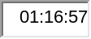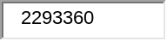
Bottom of Form
Top of Form
Showing 2 of 4 |  | Next> |  | Page: 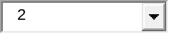 GO |  | <Prev
Bottom of Form
16 | Top of Form  Bottom of Form
  A technician is asked to secure the privileged EXEC mode of a switch by requiring a password. Which type of password would require this login and be considered the most secure?
   | console
   | enable
   | enable secret
   | VTY
17 | Top of Form  Bottom of Form
  Which two types of media can provide bandwidth up to 1 Gb/s? (Choose two.)
  10 BASE-T
  100 BASE-T
  100 BASE-FX
  1000 BASE-TX
  1000 BASE-SX
18 | Top of Form  Bottom of Form
  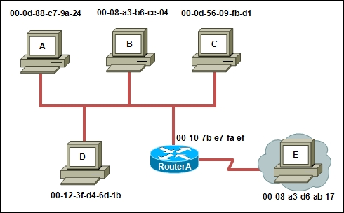
  Refer to the exhibit. Host A is trying to send data to host E. When host A sends out an ARP request, what response should be received?
  00-08-a3-d6-ab-17
  00-10-7b-e7-fa-ef
  00-0d-88-c7-9a-24
  Destination Unreachable from RouterA
19 | Top of Form  Bottom of Form
  When connectionless protocols are implemented at the lower layers of the OSI model, what is usually used to acknowledge that the data was received and to request the retransmission of missing data?
  IP
  UDP
  Ethernet
  a connectionless acknowledgement
  an upper-layer, connection-oriented protocol or service
20 | Top of Form  Bottom of Form
  A network has grown too large for technicians to configure network addresses and hosts files for name resolution. Which two application layer services should be added to the server to allow these needs to be satisfied dynamically? (Choose two.)
  DNS
  FTP
  DHCP
  HTTP
  SMTP
21 | Top of Form  Bottom of Form
  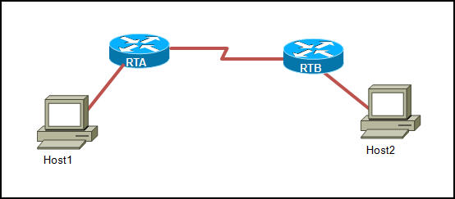
  Refer to the exhibit. Host1 is in the process of setting up a TCP session with Host2. Host1 has sent a SYN message to begin session establishment. What happens next?
  Host1 sends a segment with the ACK flag = 0, SYN flag = 0 to Host2.
  Host1 sends a segment with the ACK flag = 1, SYN flag = 0 to Host2.
  Host1 sends a segment with the ACK flag = 1, SYN flag = 1 to Host2.
  Host2 sends a segment with the ACK flag = 0, SYN flag = 1 to Host1.
  Host2 sends a segment with the ACK flag = 1, SYN flag = 0 to Host1.
  Host2 sends a segment with the ACK flag = 1, SYN flag = 1 to Host1.
22 | Top of Form  Bottom of Form
  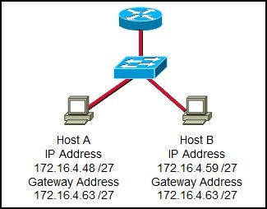
  Refer to the exhibit. On the basis of the IP configuration that is shown, what is the reason that Host A and Host B are unable to communicate outside the local network?
  Host A was assigned a network address.
  Host B was assigned a multicast address.
  Host A and Host B belong to different networks.
  The gateway address was assigned a broadcast address.
23 | Top of Form  Bottom of Form
  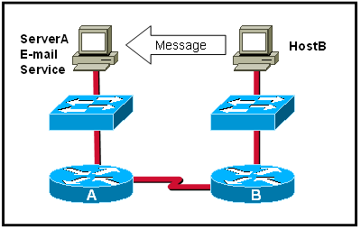
  Which statement describes the correct use of addresses to deliver an e-mail message from HostB to the e-mail service that is running on ServerA?
   | HostB uses the MAC address of ServerA as the destination.
   | Router B uses a Layer 3 network address to route the packet.
   | Router A uses the Layer 4 address to forward the packet to Router B.
   | Via the use of a Layer 3 address, ServerA assigns the message to the e-mail service.
24 | Top of Form  Bottom of Form
  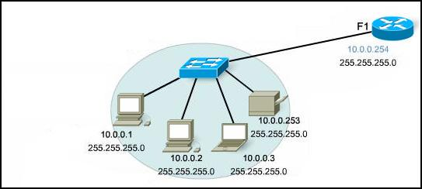
  Refer to the exhibit. A PC is connected to a network. Which action will verify that the PC can communicate with its default gateway?
  Use the ping 127.0.0.1 command.
  Use the ipconfig command.
  Use the ipconfig/all command.
  Use the ping 10.0.0.254 command.
25 | Top of Form  Bottom of Form
  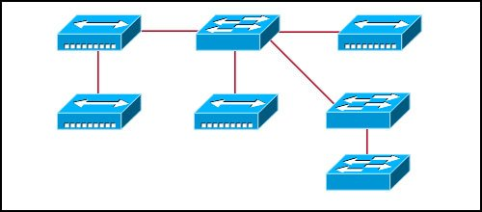
  Refer to the exhibit. What two facts can be determined about the exhibited topology? (Choose two.)
  A single broadcast domain is present
  Two logical address ranges are required.
  Three broadcast domains are shown.
  Four networks are needed.
  Five collision domains exist.
26 | Top of Form
  What three statements are true about network layer addressing? (Choose three.)
  Network layer addressing uses a hierarchy.
  It uses addresses that are 48 bits in length.
  It is used by Ethernet switches to make forwarding decisions.
  It does not support broadcasts.
  It uses a method by which the network portion of an address can be identified.
  Network layer addressing identifies each host distinctly.
27 | Top of Form  Bottom of Form
  Due to a security violation, the router passwords must be changed. What information can be learned from the following configuration entries? (Choose two.)
  Router(config)# line vty 0 3
  Router(config-line)# password c13c0
  Router(config-line)# login
  The entries specify three Telnet lines for remote access.
  The entries specify four Telnet lines for remote access.
  The entries set the console and Telnet password to "c13c0".
  Telnet access will be denied because the Telnet configuration is incomplete.
  Access will be permitted for Telnet using "c13c0" as the password.
28 | Top of Form  Bottom of Form
  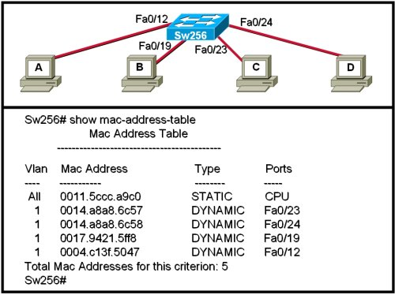
  Refer to the exhibit. When computer A sends a frame to computer D, what computers receive the frame?
  only computer D
  only computer A and computer D
  only computer B, computer C, and computer D
  all computers
29 | Top of Form  Bottom of Form
  A PC can not connect to any remote websites, ping its default gateway, or ping a printer that is functioning properly on the local network segment. Which action will verify that the TCP/IP stack is functioning correctly on this PC?
  Use the ipconfig /all command at the host’s command prompt.
  Use the ping 127.0.0.1 command at the command prompt.
  Use the traceroute command at the command prompt to identify any failures on the path to the gateway.
  Use FTP to check for connectivity to remote sites.
  Download a troubleshooting tool from the PC manufacturer's website.
30 | Top of Form  Bottom of Form
  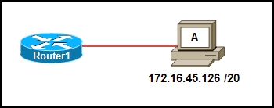
  Refer to the exhibit. Which option correctly identifies the network address, range of host addresses, and the broadcast address for the network that contains host A?
  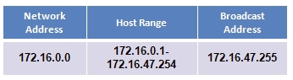
  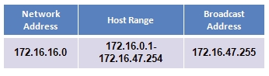
  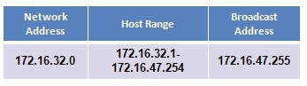
  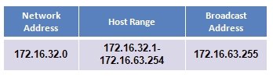
Top of Form
Showing 2 of 4 |  | Next> |  | Page: GO |  | <Prev
Bottom of Form

All contents copyright 1992-2009 Cisco Systems, Inc. Privacy Statement and Trademarks
Top of Form
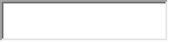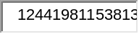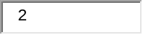
Bottom of Form
Assessment System

Skip to Time Left | Skip to Navigation | Skip to Assessment Items
Take Assessment - ENetwork Final Exam - CCNA Exploration: Network Fundamentals (Version 4.0)
Top of Form
Time Remaining: 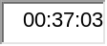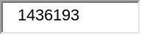
Bottom of Form
Top of Form
Showing 3 of 4 |  | Next> |  | Page: 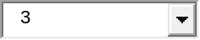 GO |  | <Prev
Bottom of Form
31 | Top of Form  Bottom of Form
  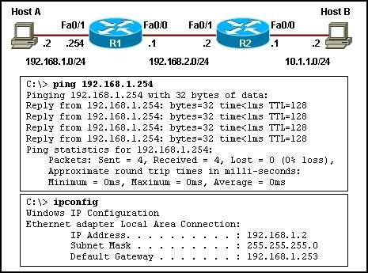
  Refer to the exhibit. Host A is unable to reach host B on the remote network. A technician attempted to ping the local gateway and the ping was successful. To verify the host configuration, the technician issued the ipconfig command. What is the likely cause of the problem?
  The local NIC is incorrectly configured.
  The subnet mask on host A is incorrectly configured.
  The IP address on host A is incorrectly configured.
  The default gateway on host A is incorrectly configured.
32 | Top of Form  Bottom of Form
  Refer to the exhibit. Host X is unable to communicate with host Y. Which command can be run at host X to determine which intermediary device is responsible for this failure?
  telnet 192.168.1.1
  ping 192.168.1.1
  ftp 192.168.1.1
  tracert 192.168.1.1
33 | Top of Form  Bottom of Form
  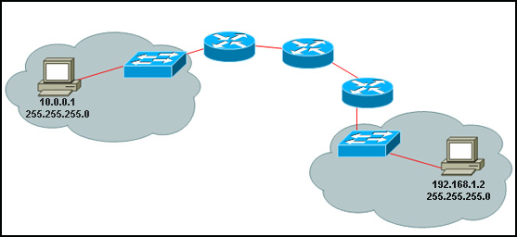
  Refer to the exhibit. A PC is communicating with another PC on a remote network. The two networks are connected by three routers. Which action will help to identify the path between the hosts?
  Use the ipconfig command at the host.
  Use the ipconfig/all command at the destination.
  Use the tracert command at the host.
  Use the ping command at the destination.
34
  What information can be gathered by using the command netstat?
  the default gateway
  the routing protocol
  active TCP connections
  the locally configured subnet mask
35
  Which device should be used for enabling a host to communicate with another host on a different network?
  switch
  hub
  router
  host
36 | Bottom of Form
  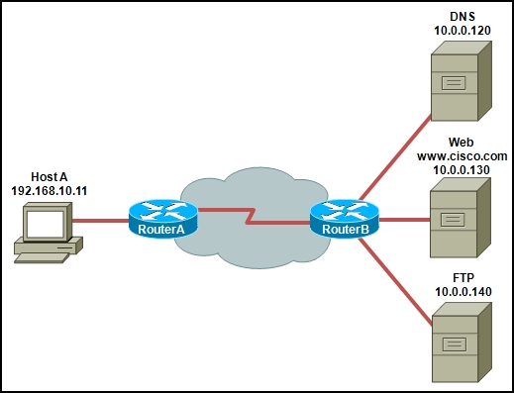
  Refer to the exhibit. Host A is requesting a web page from the web server. Which option represents the socket to which the request is made?
  80
  www.cisco.com
  10.0.0.130
  10.0.0.130:80
37 | Top of Form  Bottom of Form
  Which three addresses belong to the category of private IP addresses? (Choose three.)
   | 10.0.0.1
   | 127.0.0.1
   | 150.0.0.1
   | 172.16.0.1
   | 192.168.0.1
   | 200.100.50.1
38 | Top of Form  Bottom of Form
  Which exhibit shows the interface that is configured by the command, router(config)# interface serial 0/0/1?
  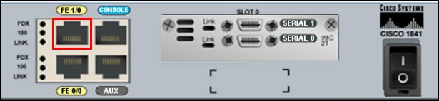
  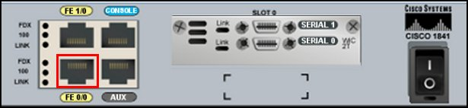
  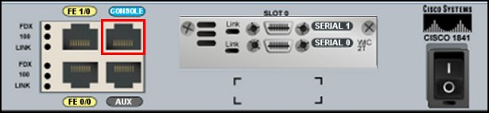
  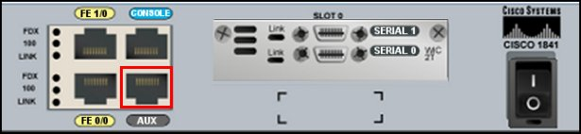
  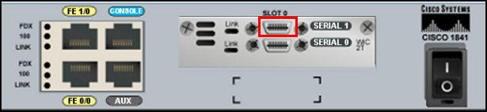
39 | Top of Form  Bottom of Form
  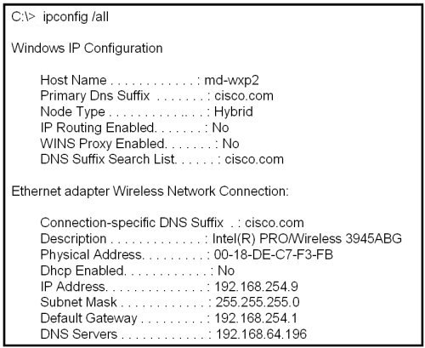
  Refer to the exhibit. A technician is working on a network problem that requires verification of the router LAN interface. What address should be pinged from this host to confirm that the router interface is operational?
  127.0.0.1
  192.168.64.196
  192.168.254.1
  192.168.254.9
  192.168.254.254
40 | Top of Form  Bottom of Form
  Which range of port numbers is assigned dynamically to client applications when initiating a connection to the server?
  0 to 255
  0 to 1023
  1024 to 49151
  greater than 65535
41 | Top of Form
  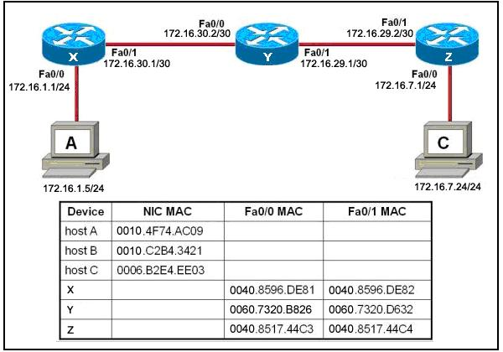
  Refer to the exhibit. Host A attempts to establish a TCP/IP session with host C. During this attempt, a frame was captured at the FastEthernet interface fa0/1 of router Y. The packet inside the captured frame has the IP source address 172.16.1.5, and the destination IP address is 172.16.7.24. What is the source MAC address of the frame at the time of capture?
  0040.8596.DE82
  0060.7320.B826
  0060.7320.D632
  0010.4F74.AC09
  0040.8596.DE81
42 | Top of Form  Bottom of Form
  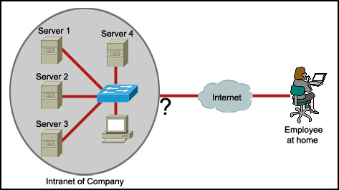
  Refer to the exhibit. An employee wants to access the organization intranet from home. Which intermediary device should be used to connect the organization intranet to the Internet to enable this access?
  hub
  switch
  router
  wireless access point
43 | Top of Form  Bottom of Form
  What happens when a host station receives a frame that contains its own MAC address in the destination field?
  The Layer 2 information is removed and the frame is pushed up to Layer 3.
  The host station will copy the information to its buffers and send it back out.
  The frame originated from the host and will be ignored.
  The Layer 3 information is added to the frame.
44
  What can the user do from the command prompt, Router(config-line)# ?
  Configure one of the network interfaces.
  Configure one of the physical or virtual lines.
  Verify the running configuration on the device.
  Configure the parameters for one of the routing protocols.
45 | Top of Form  Bottom of Form
  Refer to the exhibit. The serial interface of the router was configured with the use of the commands that are shown. The router cannot ping the router that is directly connected to interface serial 0/0/0. What should the network technician do to solve this problem?
  Configure the description at interface serial 0/0/0.
  Configure an IP address on interface serial 0/0/0.
  Remove the no shutdown command at interface serial 0/0/0
  Reboot the router.
Top of Form
Showing 3 of 4 |  | Next> |  | Page: GO |  | <Prev
Bottom of Form

All contents copyright 1992-2009 Cisco Systems, Inc. Privacy Statement and Trademarks
Top of Form
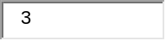
Bottom of Form
Assessment System

Skip to Time Left | Skip to Navigation | Skip to Assessment Items
Take Assessment - ENetwork Final Exam - CCNA Exploration: Network Fundamentals (Version 4.0)
Top of Form
Time Remaining: 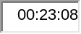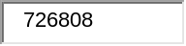
Bottom of Form
Top of Form
Showing 4 of 4 |  | Next> |  | Page: 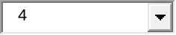 GO |  | <Prev
Bottom of Form
46 | Top of Form
  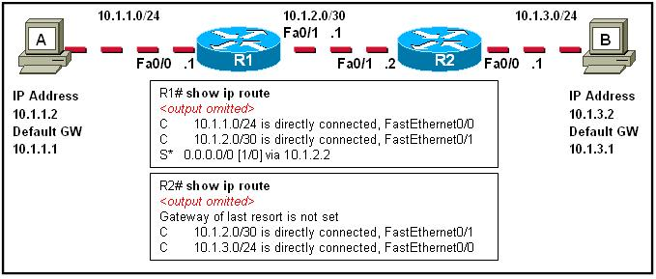
  The tracert 10.1.3.2 command was issued on computer A. Computer A can ping other addresses on the local subnet. Computer A sent the first ICMP packet toward computer B with a TTL value of 1. A protocol analyzer that was running on computer B showed that the packet never reached its destination. Why did the packet not reach the destination?
  There is a TCP/IP problem on computer A.
  There is a routing loop between R1 and R2.
  R1 does not have a route for the destination network.
  The TTL for the packet was decreased to zero by R1.
47 | Top of Form  Bottom of Form
  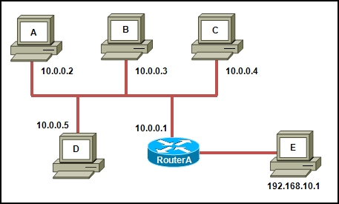
  Refer to the exhibit. Host A uses router A as its default gateway. If host A sends an ICMP echo request to 172.16.10.0, what ICMP response will host A receive.
  echo reply
  source quench
  route redirection
  destination unreachable
48 | Top of Form  Bottom of Form
  Which information is used by the router to determine the path between the source and destination hosts?
  the host portion of the IP address
  the network portion of the IP address
  host default gateway address
  the MAC address
49 | Top of Form  Bottom of Form
  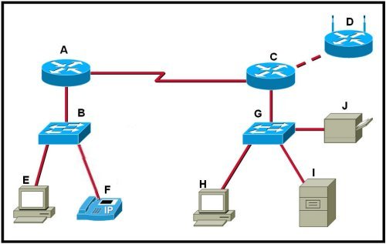
  Refer to the exhibit. Which set of devices contains only intermediary devices?
  A, B, D, G
  A, B, E, F
  C, D, G, I
  G, H, I, J
50
  Which two functions of the OSI model occur at layer two? (Choose two.)
  physical addressing
  encoding
  routing
  cabling
  media access control
51 | Top of Form
  Which option shows how a router will route packets to a remote network?
  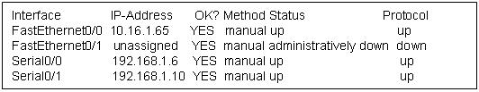
  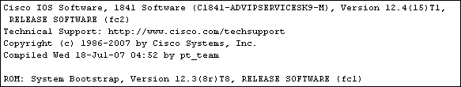
  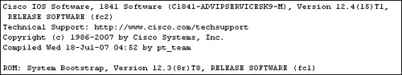
  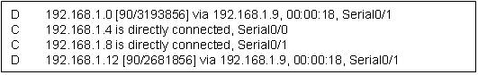
52
  What type of network is maintained if a server takes no dedicated role in the network?
  mainframe
  client/server
  peer-to-peer
  centralized
53 | Top of Form  Bottom of Form
  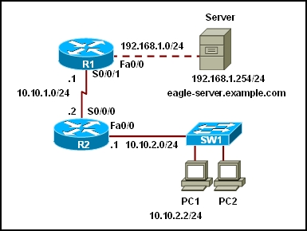
  Refer to the exhibit. A web browser running on host PC1 sends a request for a web page to the web server with an IP address 192.168.1.254/24. What sequence of steps will follow in order to establish the session before data can be exchanged?
  The session will be initiated using UDP. No additional acknowledgment will be required to establish the session.
  The session will be initiated using TCP. No additional acknowledgment will be required to establish the session.
  The session will be initiated using UDP. The returned web page will serve as an acknowledgment for session establishment.
  The session will be initiated using TCP. A three-way handshake must be successfully completed before the session is established.
Top of Form
Showing 4 of 4 |  | Next> |  | Page: GO |  | <Prev
Bottom of Form

All contents copyright 1992-2009 Cisco Systems, Inc. Privacy Statement and Trademarks
Top of Form
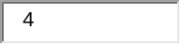
Bottom of Form
Assessment System

Skip to Time Left | Skip to Navigation | Skip to Assessment Items
Take Assessment - ENetwork Final Exam - CCNA Exploration: Network Fundamentals (Version 4.0)
Top of Form
Time Remaining: 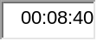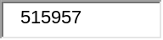
Bottom of Form
Top of Form
Showing 1 of 4 |  | Next> |  | Page: 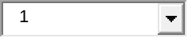 GO |  | <Prev
Bottom of Form
1 | Top of Form  Bottom of Form
  Which physical component is used to access and perform the initial configuration on a new unconfigured router?
  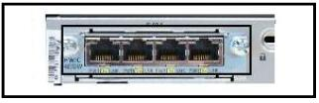
  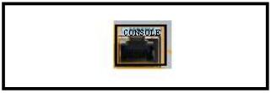
  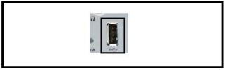
  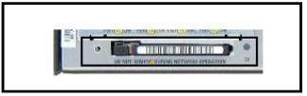
  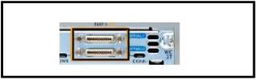
2 | Top of Form  Bottom of Form
  A routing issue has occurred in your internetwork. Which of the following type of devices should be examined to isolate this error?
  access point
  host
  hub
  router
  switch
3
  Which option correctly identifies the interface or interfaces used to connect the router to a CSU/DSU for WAN connectivity?
  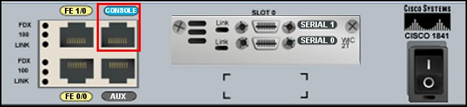
  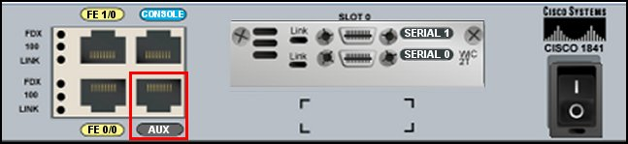
  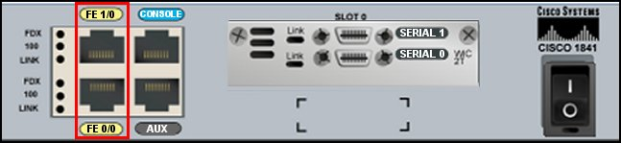
  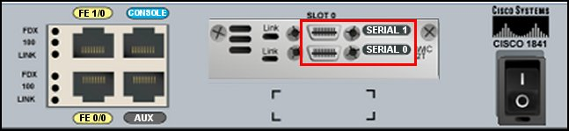
4 | Top of Form  Bottom of Form
  A user sees the command prompt: Router(config-if)# . What task can be performed at this mode?
  Reload the device.
  Perform basic tests.
  Configure individual interfaces.
  Configure individual terminal lines.
5 | Top of Form  Bottom of Form
  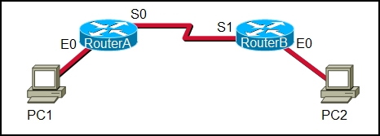
  Refer to the exhibit. A network administrator remotely accesses the CLI of RouterB from PC1 using Telnet. Which statement is true about this connection?
  The data is automatically encrypted.
  A Telnet server process is running on PC1.
  The connection is made through a VTY session on the router.
  A GET request was sent to RouterB to retrieve data during this session.
6 | Top of Form  Bottom of Form
  Refer to the exhibit. Host C is able to ping 127.0.0.1 successfully, but is unable to communicate with hosts A and B in the organization. What is the likely cause of the problem?
  Hosts A and B are not on the same subnet as host C.
  The IP addresses on the router serial interfaces are wrong.
  The subnet mask on host C is improperly configured.
  The FastEthernet interface fa0/0 of router 1 is wrongly configured.
7 | Top of Form  Bottom of Form
  Which topology divides the collision domain and provides full media bandwidth to the hosts in the network?
  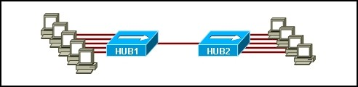
  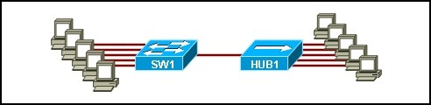
  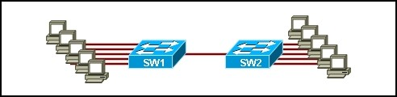
  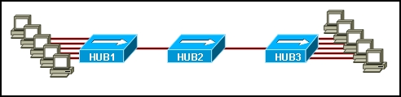
8 | Top of Form  Bottom of Form
  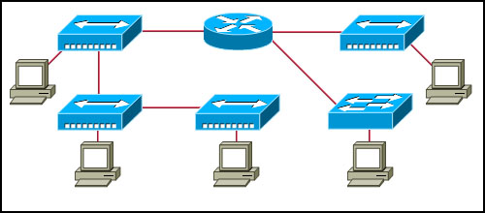
  Refer to the exhibit. Assume all devices are using default configurations. How many subnets are required to address the topology that is shown?
  1
  3
  4
  5
  7
9 | Top of Form  Bottom of Form
  Which OSI layer uses the header information to reassemble the data segments into streams?
  application layer
  network layer
  presentation layer
  session layer
  transport layer
10 | Top of Form  Bottom of Form
  Two routers are connected via their serial ports in a lab environment. The routers are configured with valid IP addresses, but they cannot ping each other. The show interface serial0/0 command shows that the serial0/0 interface is up but the line protocol is down. What could be the cause of this problem?
  The no shutdown command has not been applied to the interfaces.
  The clock rate command has not been entered on the DCE interface.
  The interface timers are not cleared.
  The FastEthernet interface is emulating a serial interface by assigning it a timing signal.
11 | Top of Form  Bottom of Form
  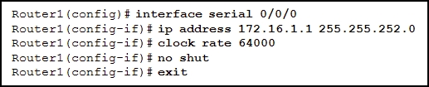
  Refer to the exhibit. Which option shows the correct topology given the configuration of Router1?
  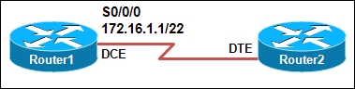
  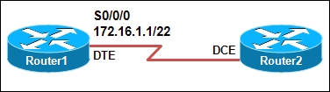
  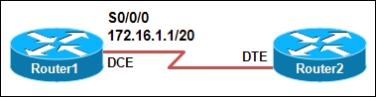
  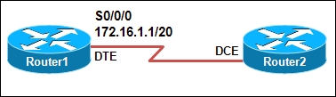
12 | Top of Form  Bottom of Form
  Which password is automatically encrypted when it is created?
  vty
  aux
  console
  enable secret
  enable password
13 | Top of Form  Bottom of Form
  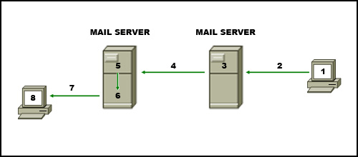
  Refer to the exhibit. The diagram represents the process of sending email between clients. Select the list below that correctly identifies the component or protocol used at each numbered stage of the diagram.
  1.MUA 2.MDA 3.MTA 4.SMTP 5.MTA 6.POP 7.MDA 8.MUA
  1.MUA 2.POP 3.MDA 4.SMTP 5.MTA 6.MDA 7.SMTP 8.MUA
  1.MUA 2.POP 3.SMTP 4.MDA 5.MTA 6.SMTP 7.POP 8.MUA
  1.MDA 2.SMTP 3.MTA 4.SMTP 5.MTA 6.MUA 7.POP 8.MDA
  1.MUA 2.SMTP 3.MTA 4.SMTP 5.MTA 6.MDA 7.POP 8.MUA
14 | Top of Form  Bottom of Form
  What is the effect of using the Router# copy running-config startup-config command on a router?
  The contents of ROM will change.
  The contents of RAM will change.
  The contents of NVRAM will change.
  The contents of flash will change.
15 | Top of Form  Bottom of Form
  Refer to the exhibit. A technician uses the nslookup command on the PC and views the output that is displayed in the exhibit. What is the IP address of the primary domain name server used by the host?
  10.10.10.32
  192.168.1.5
  192.168.1.99
  192.168.2.100
Top of Form
Showing 1 of 4 |  | Next> |  | Page: GO |  | <Prev
Bottom of Form

All contents copyright 1992-2009 Cisco Systems, Inc. Privacy Statement and Trademarks
Top of Form
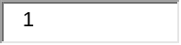
Bottom of Form

